<Exp no : 4>

<!DOCTYPE html>

<html lang="en">

<head>

    <meta charset="UTF-8">

    <meta name="viewport" content="width=device-width, initial-scale=1.0">

    <title>Document</title>

</head>

<body>

    <h1>To compare 2 strings using strict equality method</h1>

    <label for="s1">Enter first string</label>

    <input type="text" id="s1">

    <br><br>

    <label for="s2">Enter second string</label>

    <input type="text" id="s2">

    <br><br>

    <button onclick="comparison()">Output</button>

    <p id="result"></p>

    <br><br>

     <script src="script.js"></script>

</body>

</html>

**JAVASCRIPT CODE**

function comparison(){

    let a = document.getElementById("s1").value;

    let b = document.getElementById("s2").value;

    if(a===b){

        document.getElementById("result").innerHTML="The two strings are equal";}

    else{

        document.getElementById("result").innerHTML="The two strings are not equal";

    }}

**OUTPUT:**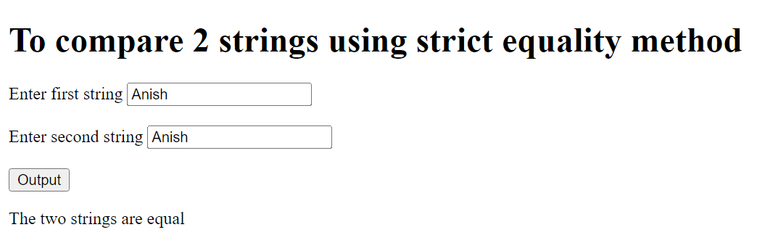

**//comparison using match method**

const string = "i am learning Javascript not Java ";

const d = /Java/;

let result = string.match(d);

console.log(result);

**OUTPUT:**

[ 'Java',

index: 14,

input: 'i am learning Javascript not Java ',

groups: undefined]

**//comparison using matchall method**

const sentence = "ANISH1ANISH2";//pattern having ANISH followed by digit

const re = /ANISH\d/g;//finding matches in the string for the given regular expression

let results = sentence.matchAll(re);

for(result of results){

    console.log(result);

}

**OUTPUT:**

[ 'ANISH1', index: 0, input: 'ANISH1ANISH2', groups: undefined ]

[ 'ANISH2', index: 6, input: 'ANISH1ANISH2', groups: undefined ]

**//comparison using mathematical operators**

console.log("b" > "a");

**OUTPUT:**

true

console.log("anish" == "Anish");

**OUTPUT:**

false

console.log("132" > "321");

**OUTPUT:**

false